**Experiment-5**

**Missionaries Cannibal problem**

**AIM:**

To write and execute the python program for Missionaries Cannibal problem.

**ALGORITHM:**

1. **State Representation:**
   * Define a data structure to represent the current state of the problem. In this case, the state should include the number of missionaries and cannibals on each side of the river, as well as the position of the boat.
2. **Define Valid Moves:**
   * Identify and define the valid moves that can be performed in the problem. A move typically involves moving a certain number of missionaries and cannibals from one side of the river to the other. Ensure that the move is valid and doesn't violate any rules (e.g., having more cannibals than missionaries on either side).
3. **Implement Depth-First Search (DFS):**
   * Use a DFS algorithm to explore all possible states of the problem. Start with the initial state and perform valid moves to generate new states. Keep track of visited states to avoid infinite loops.
4. **Goal Test:**
   * Define a goal test to check whether the current state represents a valid solution to the problem. The goal is typically to move all missionaries and cannibals from one side of the river to the other.
5. **Print or Output Solution:**
   * Once a solution is found, print or output the sequence of moves that lead to the goal state. You may also choose to print the intermediate states to show the progression of the solution.

**CODING:**

#Python program to illustrate Missionaries & cannibals Problem

#This code is contributed by Sunit Mal

print("\n")

print("\tGame Start\nNow the task is to move all of them to right side of the river")

print("rules:\n1. The boat can carry at most two people\n2. If cannibals num greater than missionaries then the cannibals would eat the missionaries\n3. The boat cannot cross the river by itself with no people on board")

lM = 3 #lM = Left side Missionaries number

lC = 3 #lC = Laft side Cannibals number

rM=0 #rM = Right side Missionaries number

rC=0 #rC = Right side cannibals number

userM = 0 #userM = User input for number of missionaries for right to left side travel

userC = 0 #userC = User input for number of cannibals for right to left travel

k = 0

print("\nM M M C C C | --- | \n")

try:

while(True):

while(True):

print("Left side -> right side river travel")

#uM = user input for number of missionaries for left to right travel

#uC = user input for number of cannibals for left to right travel

uM = int(input("Enter number of Missionaries travel => "))

uC = int(input("Enter number of Cannibals travel => "))

if((uM==0)and(uC==0)):

print("Empty travel not possible")

print("Re-enter : ")

elif(((uM+uC) <= 2)and((lM-uM)>=0)and((lC-uC)>=0)):

break

else:

print("Wrong input re-enter : ")

lM = (lM-uM)

lC = (lC-uC)

rM += uM

rC += uC

print("\n")

for i in range(0,lM):

print("M ",end="")

for i in range(0,lC):

print("C ",end="")

print("| --> | ",end="")

for i in range(0,rM):

print("M ",end="")

for i in range(0,rC):

print("C ",end="")

print("\n")

k +=1

if(((lC==3)and (lM == 1))or((lC==3)and(lM==2))or((lC==2)and(lM==1))or((rC==3)and (rM == 1))or((rC==3)and(rM==2))or((rC==2)and(rM==1))):

print("Cannibals eat missionaries:\nYou lost the game")

break

if((rM+rC) == 6):

print("You won the game : \n\tCongrats")

print("Total attempt")

print(k)

break

while(True):

print("Right side -> Left side river travel")

userM = int(input("Enter number of Missionaries travel => "))

userC = int(input("Enter number of Cannibals travel => "))

if((userM==0)and(userC==0)):

print("Empty travel not possible")

print("Re-enter : ")

elif(((userM+userC) <= 2)and((rM-userM)>=0)and((rC-userC)>=0)):

break

else:

print("Wrong input re-enter : ")

lM += userM

lC += userC

rM -= userM

rC -= userC

k +=1

print("\n")

for i in range(0,lM):

print("M ",end="")

for i in range(0,lC):

print("C ",end="")

print("| <-- | ",end="")

for i in range(0,rM):

print("M ",end="")

for i in range(0,rC):

print("C ",end="")

print("\n")

if(((lC==3)and (lM == 1))or((lC==3)and(lM==2))or((lC==2)and(lM==1))or((rC==3)and (rM == 1))or((rC==3)and(rM==2))or((rC==2)and(rM==1))):

print("Cannibals eat missionaries:\nYou lost the game")

break

except EOFError as e:

print("\nInvalid input please retry !!")

**OUTPUT:**

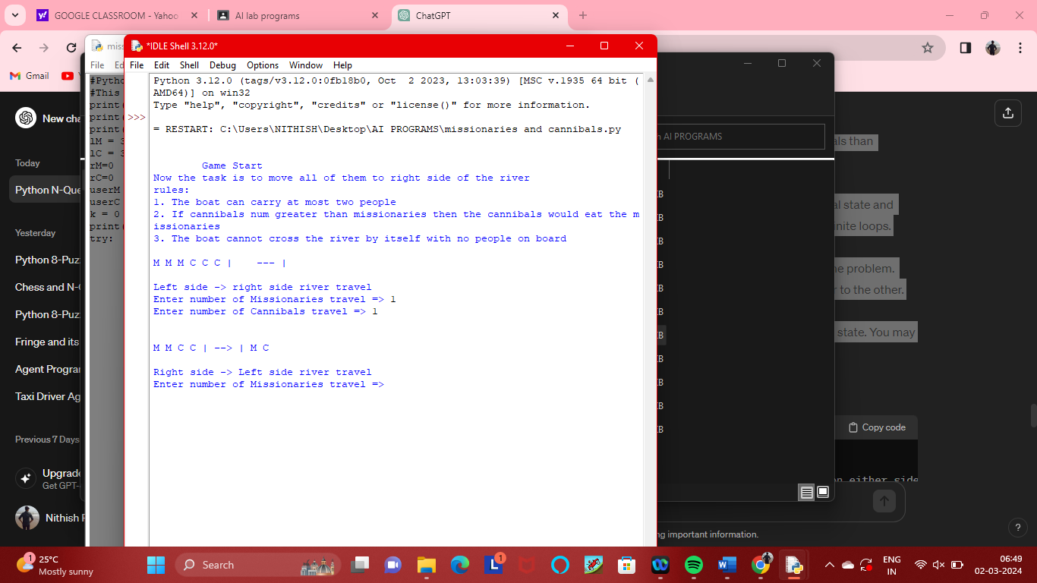

**RESULT:**

Thus the output has been successfully written and verified.